If Condition-

Syntax-

If expression:

Statement

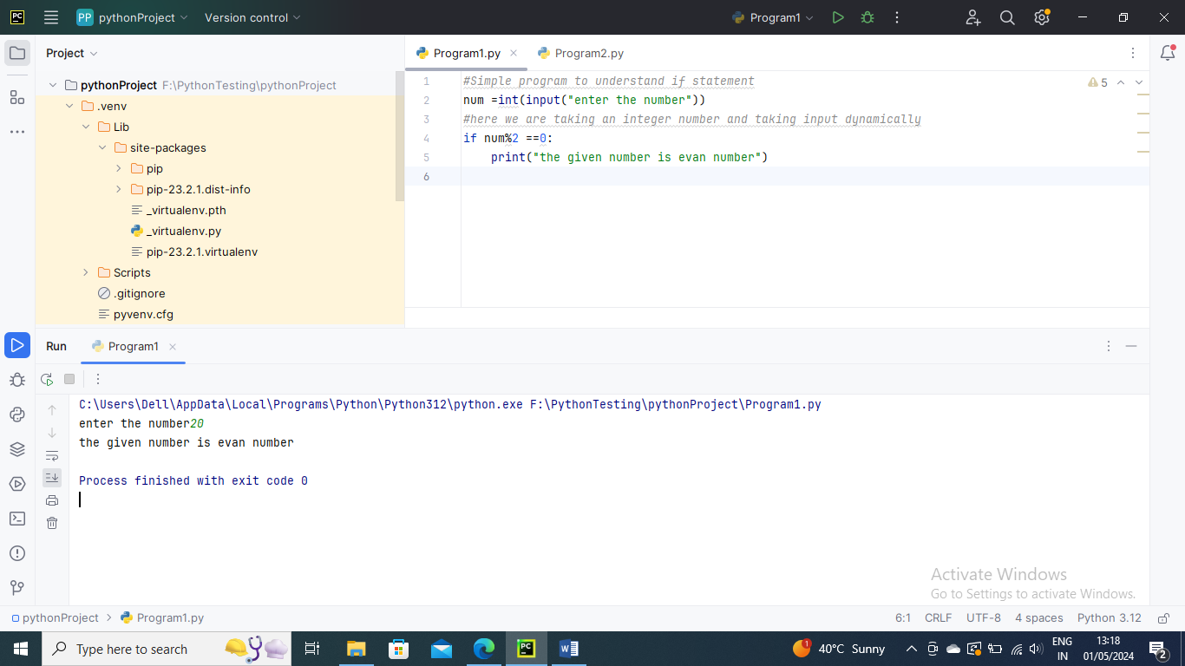

Another example

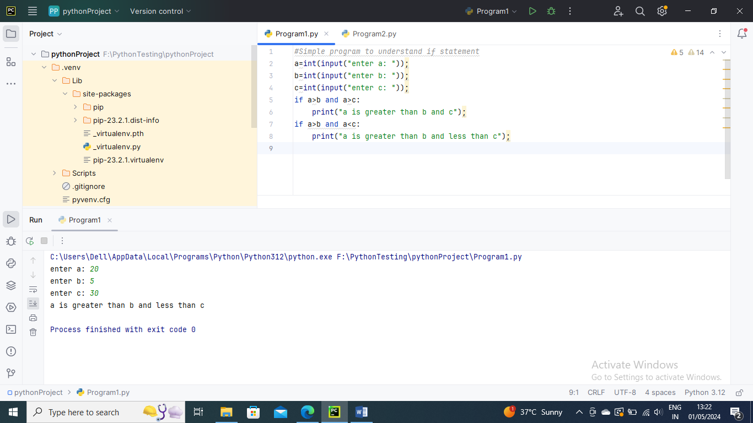

If-else statement

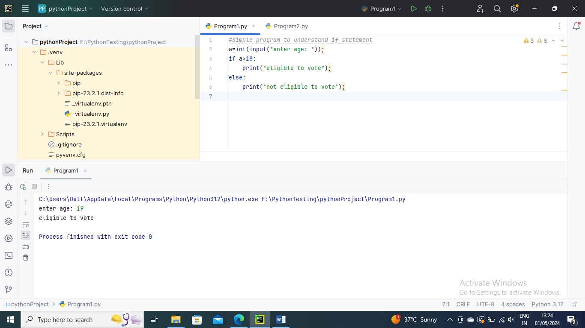

The elif statement (it’s like else I statement)

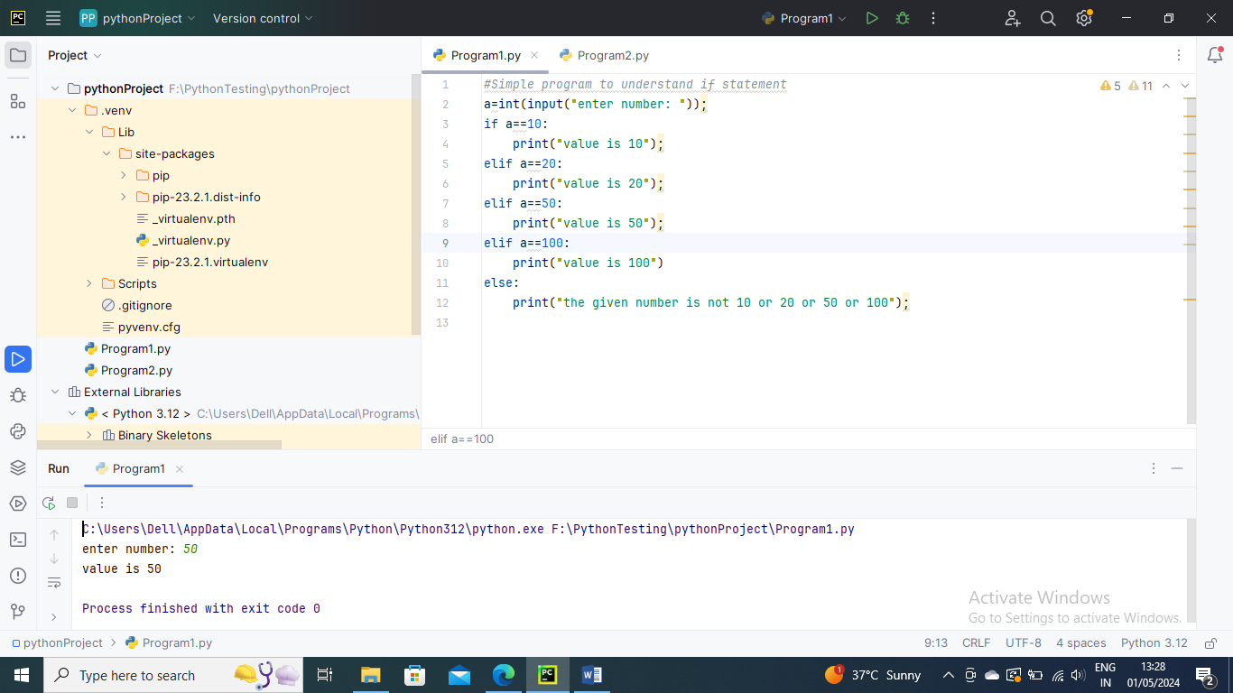

----------------

Python Loops

Below are the loops in Python

While loop

For loop

Nested loop – loop inside another loop

For loop –

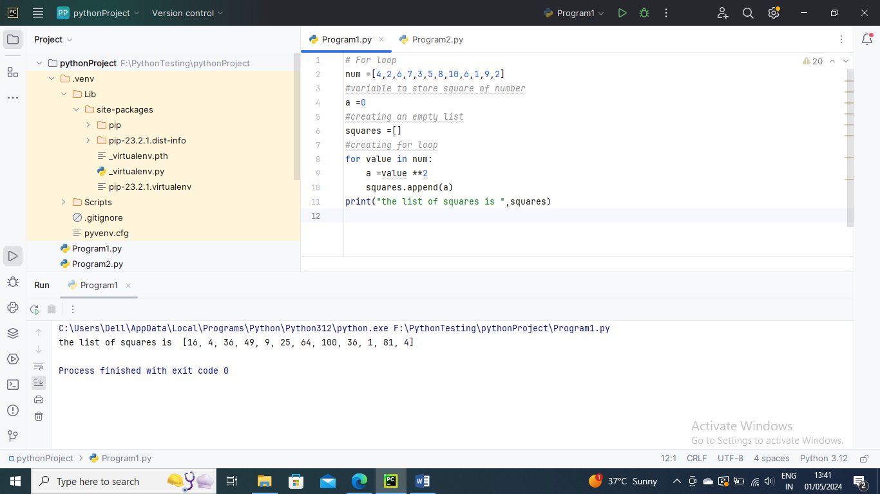

Using else statement with for loop

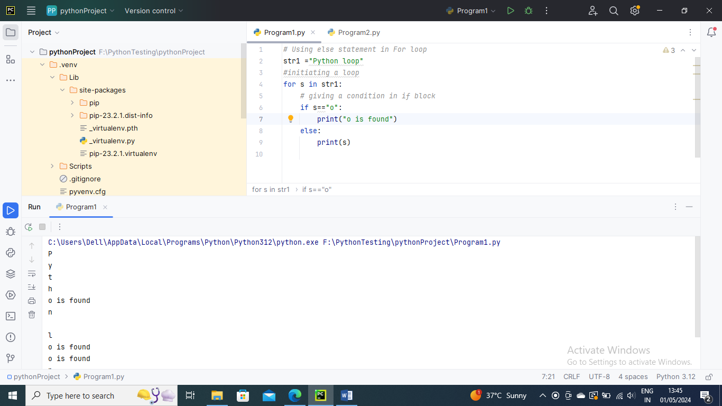

range() function –

With help of range function we may produce a series of numbers, range(10) will produce valies between 0 and 9 (10 numbers)

We can give specific start, stop and step size values in manner range (start, stop, step size). If step size is no specified it default to 1

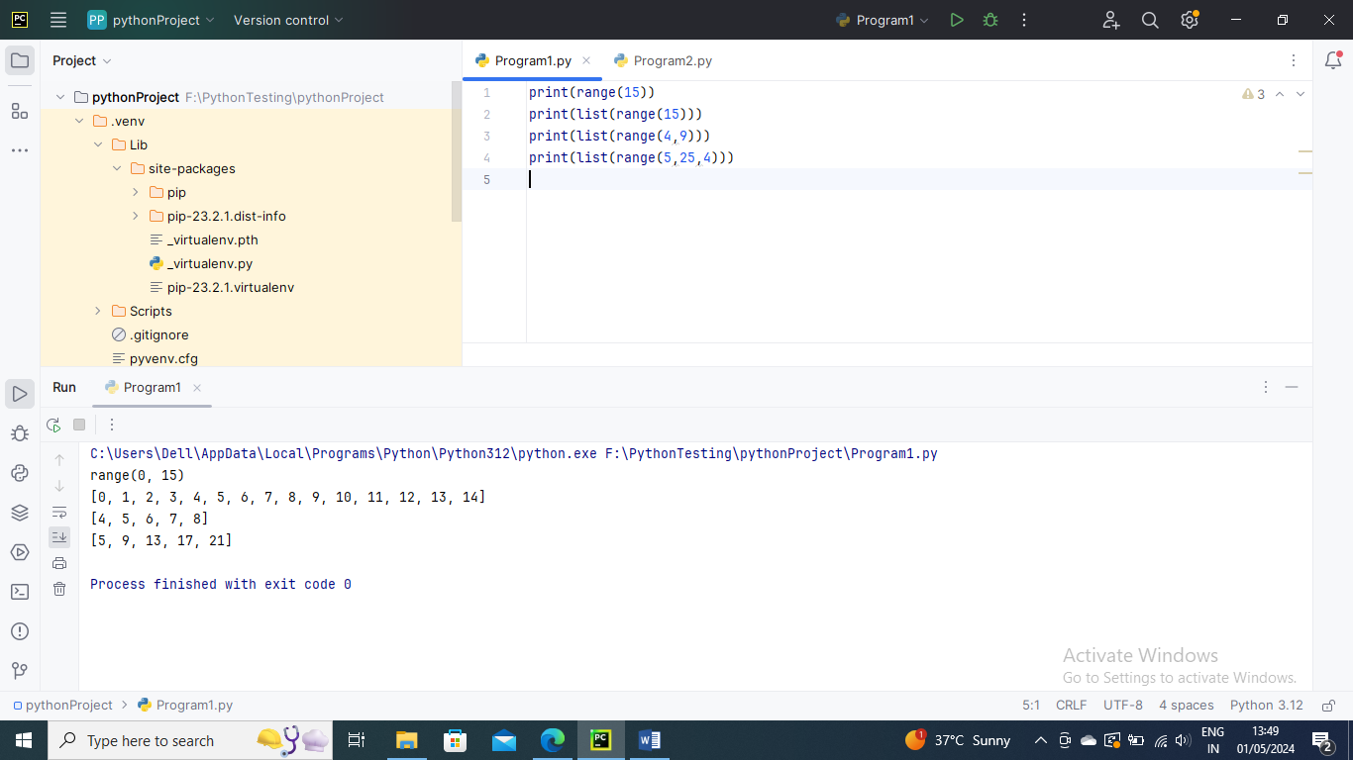

While loop –

Syntax –

While <condition>:

{ code block }

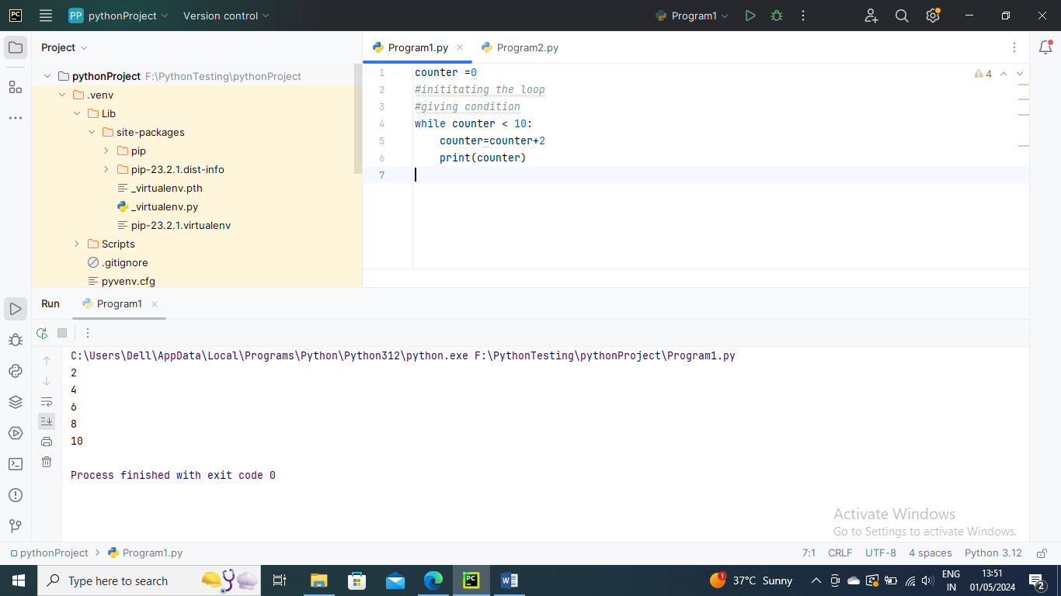

Using else statement with While loop

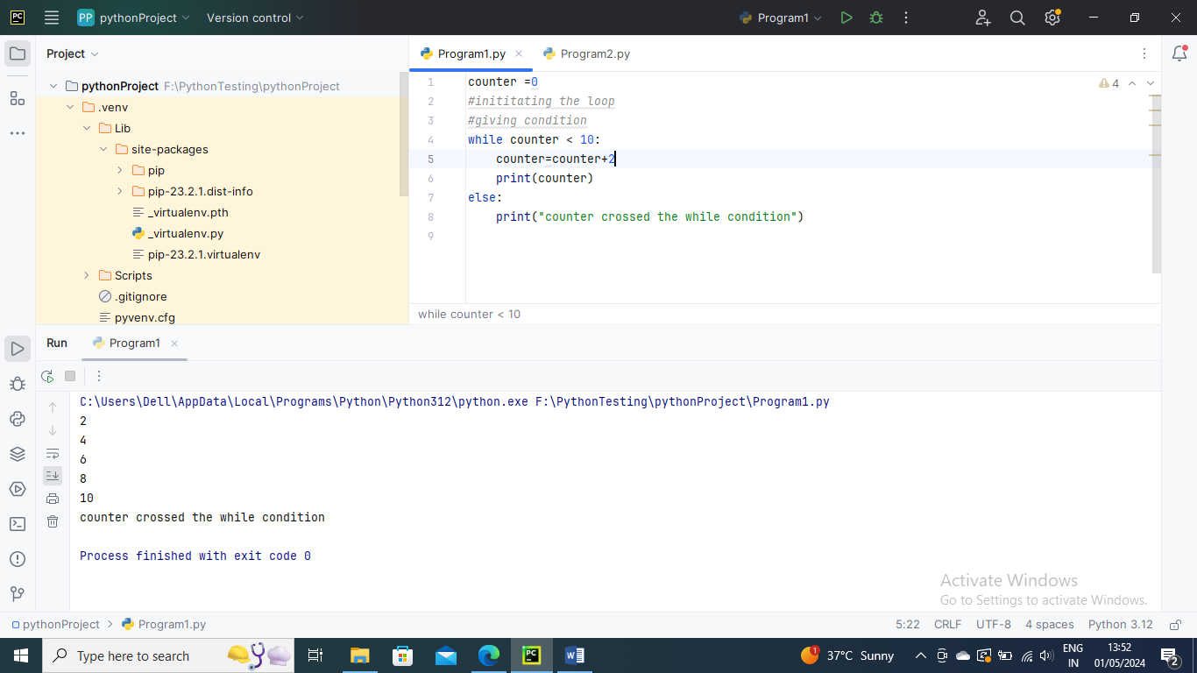

Loop Control Statements

Continue –

It returns control to the beginning of the loop

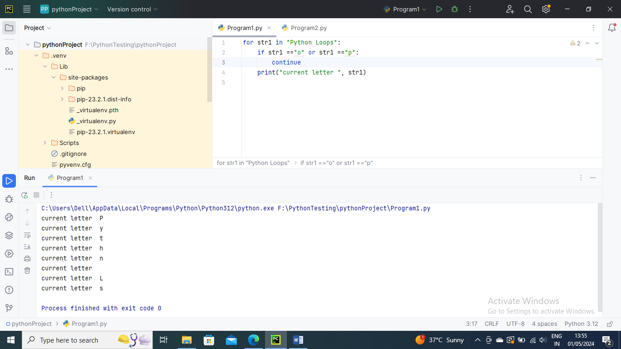

Break –

It stops the execution of the loop when break statement is reached

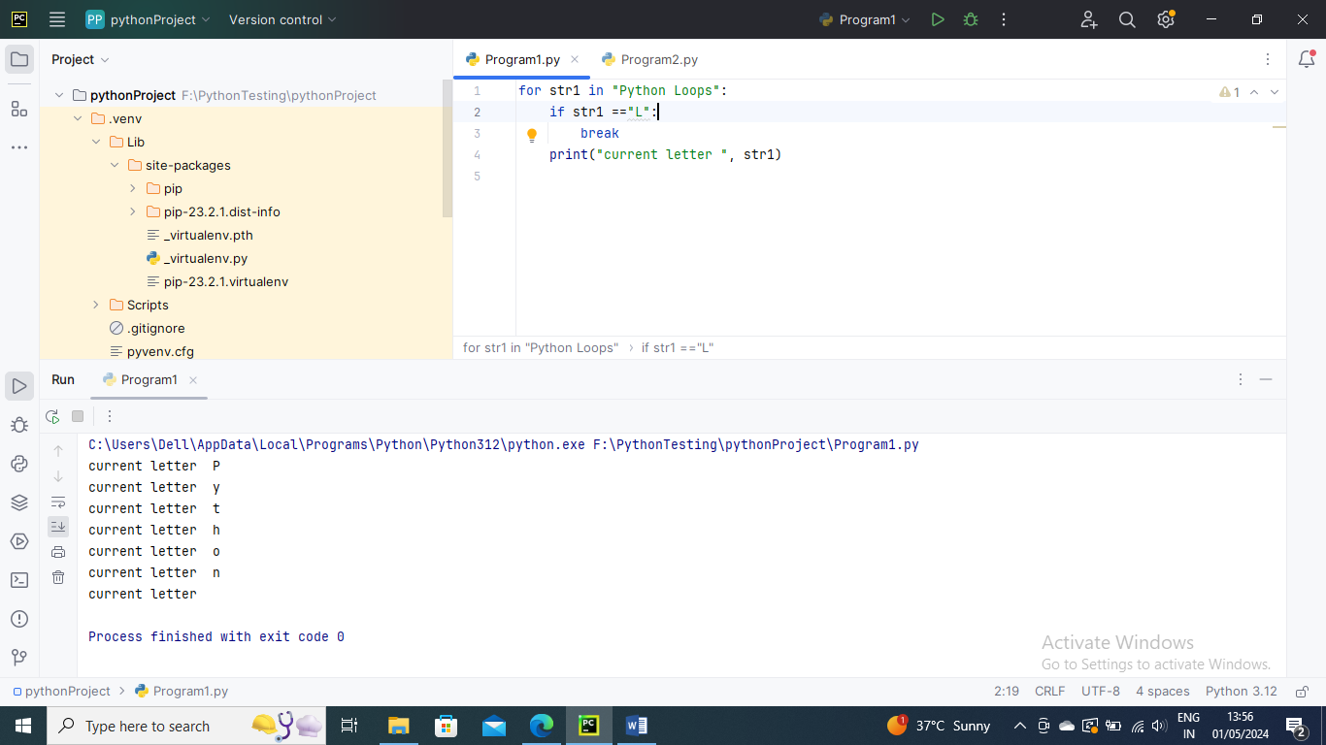

Pass Statement –

We will use when we wish no code to be executed

